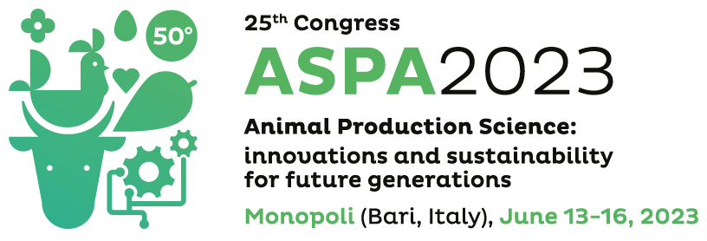
Attachment 1
The undersigned Dr. __________________________________, born in (city) _________________________ (Country ______), in date ____/____/_________, with the residence in ________________________________ (Country ____) street/square ______________________________________________________________________ ZIP code _____________
Telephone _____________________________ mobile phone _______________________________
ASKS
to participate
in the Third Edition of the “ASPA Young Researchers Competition – Oral Presentations”
in the Third Edition of the “Best Poster Competition”
For this,
DECLARES
- To be included in the list of authors of the paper with the following code (obtained by the online submission system after the submission procedure) ________________ and with the following title __________________________________________________________________________________
- To have the position of ________________at the University/Research Center of____________________________________
- To have no more than 35 years of age
- My commitment to register for the 75th EAAP congress in Florence as a speaker of a theatre presentation in case of award and to confirm by mail to aspa@unitus.it this condition no later than the early registration deadline that the 75th EAAP congress will provide.
- To authorize the treatment of the personal data according to the low n. 675/96;
- To be aware that false declarations are punishable by law.
The undersigned attaches to this application:
Signature
____________________
- Copy of a valid identity document.

